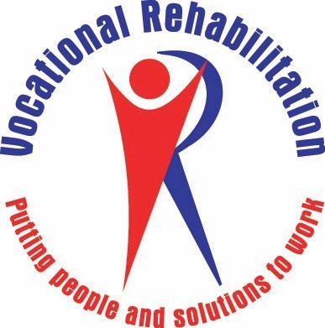

Department of Vocational Rehabilitation
Pre-Approval Form
Vendor Name: Address:
Course Title: Course Dates:

Contact Hours Requested:

Course Description: Original or copy of any printed literature describing course must be attached. Such material should contain description of contents of course.
How will this training help me in my current job or a job in DVR that I aspire to?
Expenses to be paid from Budget Unit #
Travel Registration
Lodging Materials Total
Meals Other
Name: Last First: Middle:
This is to certify that I authorize the Department of Vocational Rehabilitation, at its discretion, to deduct from my pay any or all sums paid on my behalf if: My application contains any material falsification; I fail to provide the agency within 30 working days of the completion of this training evidence of successful completion; my employment with the agency is voluntarily or involuntarily terminated (a) prior to completion of three months’ employment with the agency after completion of the training specified above. Or (b) during such training, I drop the training regardless of cause without prior approval of appointing authority of my agency; or if I received financial assistance for the same training from any other source. I further authorize my educational or training institution to provide the Department of Vocational Rehabilitation with a copy of my grade report, if any, from the course listed above.
Employee’s Signature Date Office Phone
Personnel Classification Social Security #
Employee’s Office Address
Immediately upon completion of the training program, a copy of both sides of this form must be sent to the HRD Branch. Please retain the originals for your records.
For Supervisor’s Use Only
A. Is Training Relevant
B. Is it included in Career Development Plan? C. Is it cost Effective?
D. Can you afford it?
Supervisor’s Signature Date

